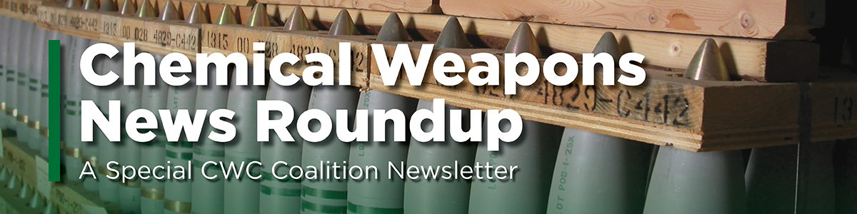

The Chemical Weapons News Roundup is produced by the Chemical Weapons Convention (CWC) Coalition, a special project of the Arms Control Association. The CWC Coalition is an independent, international civil society network committed to supporting the aims and universalization of the CWC.

We are pleased to introduce our new chemical weapons digest, the Chemical Weapons News Roundup. Sent out once per month, this news digest seeks to inform readers of important news stories, opinion and analysis pieces, official documents, and upcoming events in the chemical weapons space. - Leanne Quinn, CWC Coalition Program Assistant

You are receiving this email because you subscribed to receive the latest news and developments about chemical weapons on the Arms Control Association website. If you would like to change your subscription preferences, please click here.

News & Analysis
Jan. 15 - Feb. 14

OPCW issues Fact-Finding Mission report on chemical weapons use allegation in Kafr Zeita, Syria, on 1 October 2016 (OPCW)
The OPCW issued a report on the FFM’s investigation regarding incidents of alleged use of toxic chemicals as a weapon in Kafr Zeita, Governorate of Hama, Syrian Arab Republic, on 1 October 2016. The report concluded there are reasonable grounds to believe that the industrial chlorine cylinder was used as a weapon.

OPCW Issues Fact-Finding Mission Report on Chemical Weapons Use Allegation in Marea, Syria, in September 2015 (OPCW)
The OPCW issued on 24 January its report on the FFM’s investigation regarding incidents of alleged use of toxic chemicals as a weapon in Marea, Aleppo Governorate, Syrian Arab Republic, on 1 and 3 September 2015. The report concludes a chemical blister agent was used as a weapon.

Army continues work to dispose of chemical weapons (U.S. Army)
Destruction of the U.S. chemical weapons stockpile located at the U.S. Army Pueblo Chemical Depot, Colorado and the Blue Grass Army Depot, Kentucky has reached the 75% completion mark, with a combined total of more than 2,352 U.S. tons of chemical agent destroyed as of Jan. 14, 2022.

Static detonation chambers likely to be used to destroy Colorado’s final chemical weapons (KUNC)
A final push to rid the United States of the last of its chemical weapons is underway at an Army depot in Pueblo. It involves the use of static detonation chambers, a form of incineration that represents a change, including additional environmental permitting, in how stockpiles are being destroyed. If emissions tests come within ranges acceptable to state officials, the detonation chambers will help keep the country on track to eliminate the weapons before a congressionally-mandated deadline at the end of 2023.

International Chemical Trade Association endorse Hague Ethical Guidelines (OPCW)
The International Chemical Trade Association (ICTA) has endorsed The Hague Ethical Guidelines, a set of principles developed under facilitation by the Organisation for the Prohibition of Chemical Weapons (OPCW) to promote a culture of responsible conduct in the chemical sciences and guard against the misuse of chemistry under the norms of the Chemical Weapons Convention.

UConn Health Researcher Investigates Treatment for Eye Injuries from Mass Chemical Weapons Attacks (UConn Today)
Currently, there are no effective treatments for mustard gas injury. One of the main challenges is that a chemical weapon attack would be a mass casualty event and remedies would need to be deployed at the scale and urgency seen in battlefield-like conditions. Royce Mohan, professor of neuroscience at UConn Health, has received a grant from the National Eye Institute to investigate how another kind of chemical injury could provide answers for developing treatments for mustard gas injuries.

Arias Appointed for Second Term at OPCW (Arms Control Today)
The member states of the Organisation for the Prohibition of Chemical Weapons (OPCW) have decided to renew the appointment of Fernando Arias as the organization’s director-general. His second term will run until July 2026. Arias’ election was one of several decisions that took place during the 26th conference of states-parties to the Chemical Weapons Convention (CWC), which convened in The Hague from Nov. 29 to Dec. 3.

US will also discuss with Russia issues not reflected in Moscow’s draft documents (Tass)
The United States is going to discuss with Russia not only the issues raised by Moscow, but also security issues that were not included in the Russian proposals, a high-ranking US administration official told reporters on Saturday ahead of the upcoming Russian-American security talks. Such discussion topics include use of chemical weapons.

Presidential Proclamation To Modify The Harmonized Tariff Schedules of The United States (JD Supra)
This month a number of new and revised tariff provisions in the Harmonized Tariff Schedule of the United States (“HTSUS”) will take effect. The 2022 HTSUS introduces new subheadings covering various controlled goods, such as chemicals controlled under the Chemical Weapons Convention, hazardous chemicals controlled under the Rotterdam Convention, and certain persistent organic pollutants controlled under the Stockholm Convention.

Multimedia

Video: I24 Interview with Paul Walker on Syria and Chemical Weapons (I24/Arms Control Association)
Arms Control Association board vice chair Paul Walker speaks with France’s I24 News on Syria’s alleged continued use of chemical weapons.

Official Documents

Report of the OPCW Fact-Finding Mission In Syria Regarding the Incident of the Alleged Use of Chemical as a Weapon in Kafr Zeita, Syrian Arab Republic 1 October 2016 (OPCW)

Report of the OPCW Fact-Finding Mission in Syria Regarding the Incidents of the Alleged Use of Chemicals As a Weapon in Marea, Syrian Arab Republic, on 1 and 3 September 2015 (OPCW)

Report by the Director-General: Progress in the Elimination of the Syrian Chemical Weapons Programme (OPCW)

Looking Ahead

16 February
International Union of Pure and Applied Chemistry (IUPAC) Global Women's Breakfast - Register Here

22 February
Ten Years of Chemical Weapons Use in Syria: A Look Back and A Look Ahead - Register Here

8 -11 March
Ninety-Ninth Session of the OPCW Executive Council (EC-99) - Learn More

17 April
Save the Date! 25th Anniversary of the Chemical Weapons Convention Entry into Force. Additional details coming soon.

Have an event you would like featured? Reach out to cwcc@armscontrol.org.

The CWC Coalition News Roundup is a collection of news articles and opinion pieces related to chemical weapons that is maintained and compiled by the CWC Coalition staff. Inclusion of an article in this email does not necessarily imply endorsement of the views, authors, websites, etc. by the Coalition or any of the organizations or individuals in our network. Banner photo credit: PEO ACWA.

Selected news articles will not always reflect all viewpoints - they serve an educational purpose and are not intended to give the reader a full understanding of all perspectives on each of these complex topics.

The CWC Coalition's work is made possible by the support of Global Affairs Canada Weapons Threat Reduction Program, as well as the members and supporters of the Arms Control Association.

